6 DAYS GOLF IN SAIGON & VUNG TAU
TOUR INFORMATIONS:
- Tour Route: different rounds of golf in the finest golf courses in Saigon and Vung Tau city
- Duration: 6 days 5 nights
- Start/End: Sai Gon
- Tour Customizable: Absolutely! (Tell us your specific requirements in the inquiry form)
- Tour Categories: Tour

TRIP OVERVIEW:
Enjoy 4 different rounds of golf in the finest golf courses in Saigon and Vung Tau city. Especially, a round at Vung Tau Paradise Golf Resort which bracing sea air, three kilometres of dazzling white beach, spectacular ocean views from the tee, and a challenging 27-holes of championship golf.

TRIP DETAIL:
Day 1: Arrive in Saigon

You will be met upon arrival and private transfer to hotel in the city centre. Check-in hotel and rest of time at your own leisure. Overnight at hotel in Saigon.

Day 2: Golf at Vietnam Golf & CC (Breakfast)

After having breakfast at hotel, you will be driven to Vietnam Golf & Country Club in Thu Duc district (40 km, ~ 45 minutes). Experience a round of golf at one of the most scenic golf resort in Southern Vietnam. Overnight at hotel in Saigon.

Day 3: Golf at Song Be Golf Resort (B)

Pick up at the hotel lobby. Drive to Song Be Golf Resort, in Binh Duong province (distance: 50 km, ~ 60 minutes by drive). Song Be Golf Resort is well known for being the first international standard championship course in Vietnam and one of the most challenging and stimulating in the country, Song Be Golf Resort has been gently crafted out of the beautiful landscape and features numerous lakes, tree lined fairways and subtle undulating greens. Tee-off and enjoy a round of 18 holes golf. After the game, you will be transferred back to the hotel. Overnight at hotel in Sai Gon City.

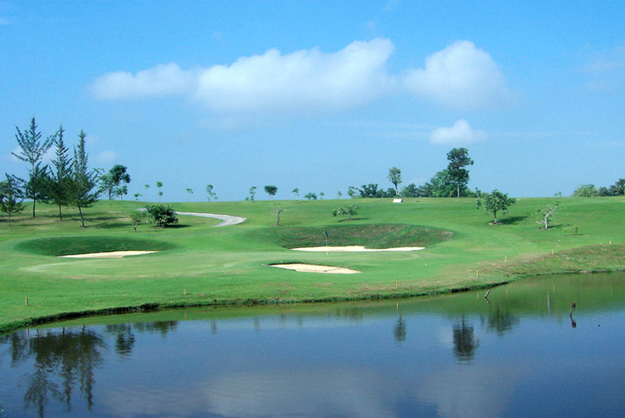

Day 4: Golf at Long Thanh Golf &CC - Vung Tau (B)

Breakfast at hotel, you will be driven to Long Thanh Golf & Country Club in Dong Nai (65 km, 1 hour and 20 minutes). Tee off and enjoy the spectacular view from the tee-boxes, watch your ball rolling beside meandering waterways and make your put on the island greens. Continue driving to Vung Tau (~60km). Check-in hotel Imperial Hotel. Overnight at hotel in Vung Tau city.

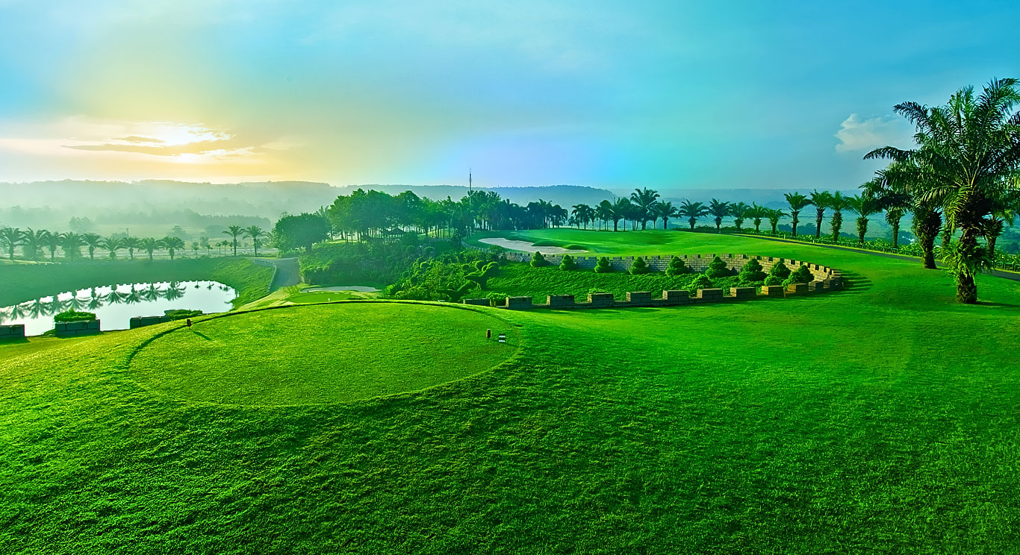

Day 5: Golf at Vung Tau Paradise Golf Resort - Saigon (Breakfast)
Breakfast at hotel and then we will drive you to the Paradise Golf Club - Vietnam's first seaside golf course, and offers a challenging play to golfers of all levels. The 6,830-yard, par 72 18-hole course is the most widely played - a testing, links-style course affording spectacular views both out over the sea and inland. Play a round and then we will transfer you to the jetty to catch 1 hour hydrofoil back to Saigon. Check-in hotel and then free at leisure. Overnight at hotel in Saigon City.

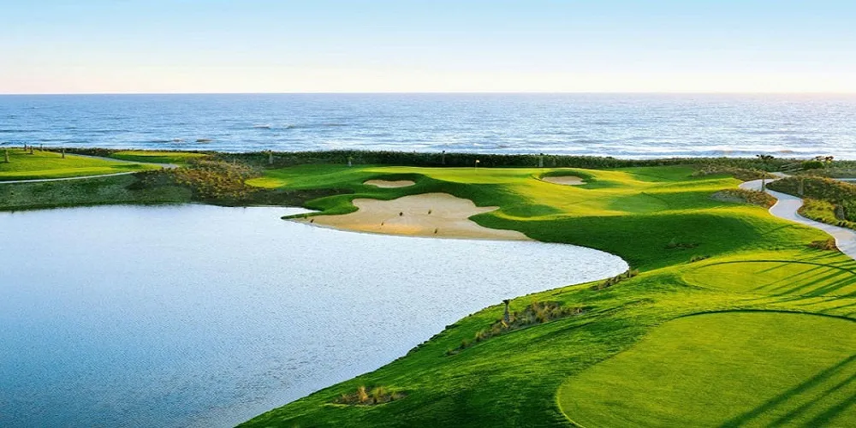

Day 6: Departure (Breakfast)

Airport transfer to catch your flight to next destination. End of service.

Trip Inclusion:
- Private transportation throughout the tour
- Green, caddie and shared cart (02 rounds of 18 hole) / week-day
- All domestic flights per programme (Economy Class)
- 02 nights stay in Premium Deluxe room at Grand Silverland Saigon Hotel ****
- 02 nights stay in Superior room at Hotel du Parc Dalat ****
- 02 nights stay in Deluxe room at Novotel Phan Thiet Hotel ****
- Daily breakfast at hotels
- All prevailing government taxes and service charges

Trip Exclusions
- Visa to Vietnam (must obtain before traveling)
- Weekend surcharges for green and caddie fees
- Surcharges for National Holidays, New Year or Xmas
- Daily personal expenses
- Personal medical and travel insurances
- Tip and gratuities to caddies, drivers...etc

HAVE A NICE TRIP!

