7 DAYS HO CHI MINH AND HA NOI GOLF
TOUR INFORMATIONS:
- Tour Route: 7days Ho Chi Minh and Ha Noi golf
- Duration: 7 days 6 nights
- Start/End: Ho Chi Minh City
- Tour Customizable: Absolutely! (Tell us your specific requirements in the inquiry form)
- Tour Categories: Tour
TRIP OVERVIEW:
7 Days tour showing off Vietnam's cities and scenery. Begin in bustling Saigon metropolis, the former capital of Southern Vietnam and end in an elegant Hanoi city. On this tour, you will encounter golf challenges in very best golf courses across the country.

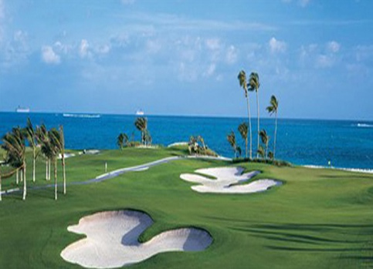

TRIP DETAIL:

Day 1: Arrive in Saigon
You will be met upon arrival and private transfer to hotel in the city centre. Check-in hotel and rest of time at your own leisure. Overnight at hotel in Saigon.

Day 2: Golf at Long Thanh Golf & CC (Breakfast)

Breakfast at hotel, you will be driven to Long Thanh Golf & Country Club in Dong Nai (65 km, 1 hour and 20 minutes). Tee off and enjoy the spectacular view from the tee-boxes, watch your ball rolling beside meandering waterways and make your put on the island greens. Back to hotel and stay overnight at hotel in Saigon City.

Day 3: Golf at Song Be Golf Resort (Breakfast)

Pick up at the hotel lobby. Drive to Song Be Golf Resort, in Binh Duong province (distance: 50 km, ~ 60 minutes by drive). Song Be Golf Resort is well known for being the first international standard championship course in Vietnam and one of the most challenging and stimulating in the country, Song Be Golf Resort has been gently crafted out of the beautiful landscape and features numerous lakes, tree lined fairways and subtle undulating greens. Tee-off and enjoy a round of 18 hole golf. After the game, you will be transferred back to the hotel. Overnight at hotel in Saigon city.

Day 4: Golf at Vietnam Golf & CC - Fly to Hanoi (Breakfast)

After having breakfast at hotel, you will be driven to Vietnam Golf & Country Club in Thu Duc district (40 km, ~ 45 minutes). Experience a round of golf at one of the most scenic golf resort in Southern Vietnam. Back to the Saigon city and then airport to take a ~ 2 hours flight in the afternoon to Hanoi. Check-in hotel and rest of time at your own leisure. Overnight at hotel in Hanoi city.

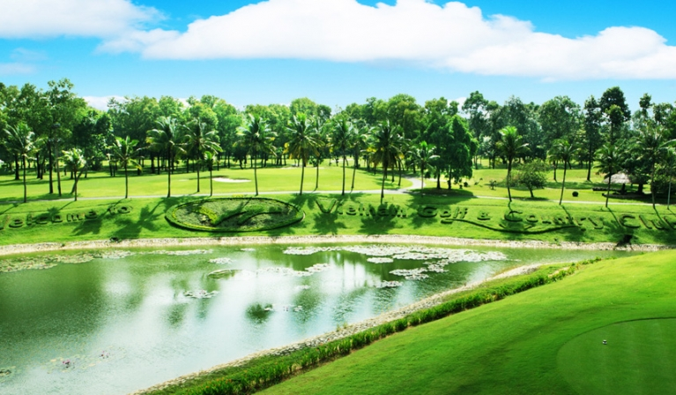

Day 5: Golf at King's Island Golf Resort (Breakfast)

Breakfast at your hotel and then we will pick you up and transfer to Son Tay town (55 km from Hanoi city) where the King's Island Golf Resort located. Take 5 minutes express boat to the Club House built on a tiny island. Enjoy the 18 holes golf round at either Lake View or Mountain View Course. Driving back to the hotel. Overnight at hotel in Hanoi city.

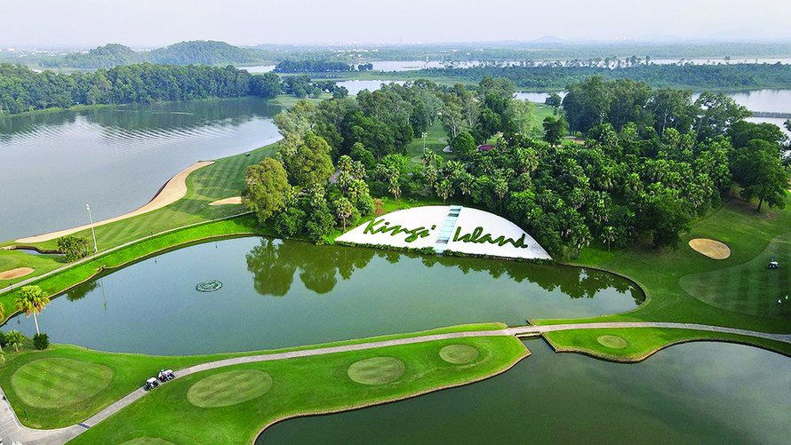

Day 6: Golf at Chi Linh Star Golf & Country Club (Breakfast)

Having breakfast at hotel. Private transfer to Chi Linh Golf & Country Club - the Northernmost challenging course - 70 minutes away from the city. Enjoy a round of golf here and then back to Hanoi city. Stay at hotel in Hanoi.

Day 7: Danang - Saigon - Departure (Breakfast)
At leisure until we will transfer you to the airport to catch your outbound flight onward. End of service.

Trip Inclusion:
- Private transportation throughout the tour
- Green, caddie and shared cart (02 rounds of 18 hole) / week-day
- 04 nights stay in Saigon & 01 night in Vung Tau
- 01 way hydrofoil ticket: Vung Tau - Saigon City
- Daily breakfast at hotels
- All prevailing government taxes and service charges

Trip Exclusions
- Visa to Vietnam (must obtain before traveling)
- Weekend surcharges for green and caddie fees
- Surcharges for National Holidays, New Year or Xmas
- Daily personal expenses
- Personal medical and travel insurances
- Tip and gratuities to caddies, drivers...etc

HAVE A NICE TRIP!

