4 DAYS 3 NIGHTS 3 ROUNDS GOLF IN HO CHI MINH
TOUR INFORMATIONS:
- Tour Route: 4 days golf tour vacation in Ho Chi Minh City
- Duration: 4 Days 3 Nights 3 Rounds
- Start/End: Ho Chi Minh City
- Tour Customizable: Absolutely! (Tell us your specific requirements in the inquiry form)
- Tour Categories: Tour
TRIP OVERVIEW:
This is one of our best selling golf itinerary for golf enthusiasts who want to experience the best 3 golf courses and city life that Saigon has to offer. the tour features 3 following courses: challenging Song Be Golf Resort, Scenic Long Thanh Golf & CC and the last one is the East Course at Vietnam Golf.

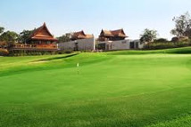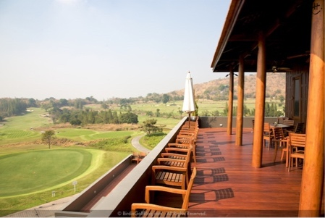

TRIP DETAIL:
Day 1: Arrive in Saigon
You will be met upon arrival by our driver. Private transfer to hotel located in the city centre. Enjoy nighlife in Saigon. Overnight at hotel in Saigon.

Day 2: Golf at Jeong San Golf Club (Breakfast)

Pick up at the hotel lobby. Drive to the Nha Rong Harbor and take the speed boat by Jeong San to Golf club and Tee-off and enjoy a round of 18 holes golf. After the game, you will be transferred back to the hotel. Overnight at hotel in Saigon city.
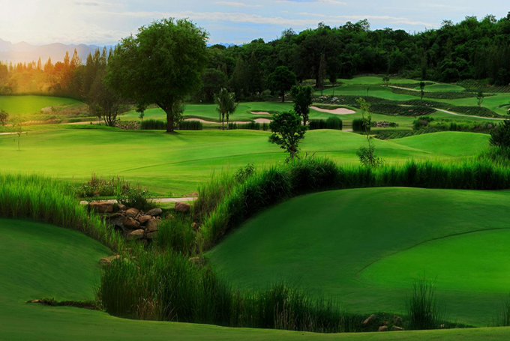

Day 3: Golf at Long Thanh Golf Club (Breakfast)

After having breakfast at hotel, you will be driven in Dong Nai (60km - 1,5 hrs). Experience a round of golf at one of the most scenic golf resort in Southern Vietnam. Transfer back to the airport to catch your afternoon flight to next destination. End of service.
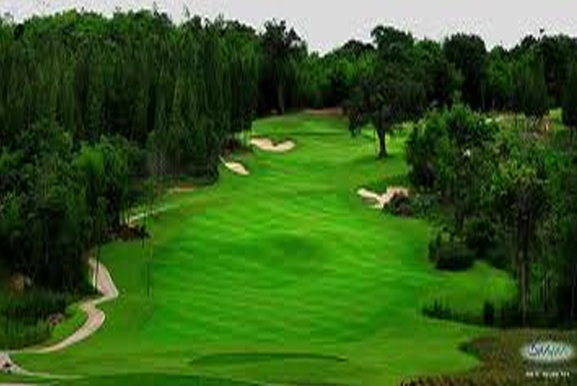
Day 4: Golf at Twin Doves Golf Club & Airport Transfer (Breakfast)
After having breakfast at hotel, you will be driven in Thu Dau Mot, Binh Duong Province (50km - 1hr 15 mins). Experience a round of golf at one of the most scenic golf resort in Southern Vietnam. Then, we transfer back to the airport to catch your afternoon flight to next destination. End of service.

Trip Inclusion:
- Private transportation throughout the tour
- Green, caddie and shared cart (02 rounds of 18 hole) / week-day
- 03 nights stay in Saigon
- Complimentary mineral water 2bottles/1pax/1game
- English speaking tour guide on arrival
- Daily breakfast at hotel served at hotels
- All prevailing government taxes and service charges

Trip Exclusions
- Visa to Vietnam (must obtain before traveling)
- Weekend surcharges for green and caddie fees
- Surcharges for National Holidays, New Year or Xmas
- Daily personal expenses
- Personal medical and travel insurances
- Tip and gratuities to caddies, drivers...etc

HAVE A NICE TRIP!

